Legal Information

Local Bar Association
- Include local bar association contact information here (if applicable)
Illinois State Bar Association
- LawyerFinder can give you the name of a lawyer in your area to discuss your legal issue for a one-time fee. You can decide whether or not to hire the lawyer after the meeting.
- Contact Information: www.illinoislawyerfinder.com
Prairie State Legal Services
- Provides free legal aid to low-income, elderly, and disabled people living in your area of Illinois
- Call (800) 331-0617 or (815) 727-5123; Monday-Thursday (9:00 AM – 1:00 PM) or apply for services online at http://pslegal.org/psls-apply-online.asp

Illinois Legal Aid Online (ILAO)

Visit www.illinoislegalaid.org from any computer or phone to access free legal information, court forms, instructional videos, and other self-help materials.

Legal Self-Help Center
- List any local self-help centers including contact information and any services provided beyond ILAO
Mental Health

Mental Health Resources
- Add local resources from this list including contact information and services provided.
National Suicide Prevention Hotline
- Free, confidential hotline available 24/7 at (800) 273-8255
Domestic Violence

Illinois Domestic Violence Hotline
- Free, confidential, multilingual hotline available 24/7 at (877) TO END DV or (877) 863-6338
Local Domestic Violence Agencies
- Add local resources from this list.
Housing

Emergency and Transitional Housing
- Add local resources from this list including contact information and services provided.
- Add local resources from this list including contact information and services provided.
Private Housing Finders
- http://www.ilhousingsearch.org/
- http://padmapper.com
- http://socialserve.com

Public Benefits

Application for Public Benefits
- Check eligibility and apply for healthcare, food, and cash assistance at (800) 843-6154 or https://abe.illinois.gov/abe/access/
Other Resources

Public Library

Havana Public Library
201 W. Adams
Phone- (309) 543-4701

Mason City Library
820 W. Chestnut Street
Phone- (217) 482-3799
Other Local Resources

- Include information for any other local resources here

What information is in this brochure?

This brochure provides contact information for local legal and social service providers who may be able to assist you.

Please note that many of these service providers have limited resources, and contacting them is not a guarantee of legal representation or any other assistance.

Are these services free?

Many of the listed service providers offer free or low-cost services. Services that are full-cost have been noted when possible. Free or low-cost service providers may use minimum income requirements or other qualifications to determine eligibility.

Where else can I go for help?

The resources listed in this brochure are not exhaustive, and information is subject to change. For additional information about local services you may want to contact your local public library.

Local Courthouse Contact Information

125 N. Plum, Havana IL
8:00 a.m. to 4:00 p.m.
(309) 543-6619
Fax (309) 543-4214
mroat@masoncountyil.org
masoncountyil.org
Circuit Clerk’s office

Address
Hours of Operation
Phone
E-mail
Website
Clerk's Office

Address
Hours of Operation
Phone
E-mail
Website
Clerk's Office

Judicial Circuit Resource List

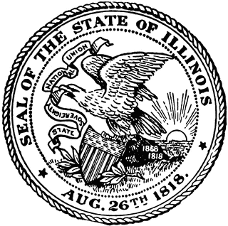

Local Resources for Residents of County

